Naan Mudhalvan

**BookBliss: A Full-Stack MERN Bookstore Application**

**Team Members:**

Rupali S (2021503042), Swathy K S (2021503052), Pooja M J (2021503532),

Bhumisvara K (2021503704)

**1. Introduction**

In today's digital age, online platforms have revolutionized the way we access and purchase books. The **Book Store Project** aims to provide a seamless and user-friendly online book-shopping experience. This project combines robust back-end data management with an interactive front-end interface, ensuring efficient and intuitive navigation for users.

With a focus on scalability, performance and user satisfaction, this project highlights the potential of the MERN stack for building dynamic, modern web applications.

**2. Project Overview**

**Purpose:**

The **Book Store Project** aims to provide an intuitive platform for managing and purchasing books, showcasing the power of the MERN stack. With CRUD functionalities for administrators and a user-friendly interface for customers, the project ensures efficient book management and a seamless shopping experience, highlighting full-stack integration and responsive design to meet diverse user needs effectively.

**Features:**

1. **User-Friendly Interface:** Intuitive and responsive UI designed for easy navigation and seamless user experience.
2. **Admin Features:** Comprehensive CRUD operations for managing book entries, including creating, reading, updating, and deleting books. Secure admin panel to oversee and manage inventory effectively.
3. **Book Browsing and Search:** Users can browse the catalog or search for books by title, author, or genre.
4. **Shopping Cart:** Add, view, and remove books from the shopping cart before proceeding to checkout.
5. **User Authentication**: Secure login and registration system to ensure personalized and safe interactions.
6. **Efficient Data Management**: Seamless communication between the front end and backend for real-time updates. MongoDB ensures reliable and scalable storage of book and user data.
7. **Responsive Design**: Fully optimized for desktops, tablets, and mobile devices, offering a consistent experience across platforms.
8. **Purchase Functionality**: Streamlined checkout process for users to buy books quickly and efficiently.

**3. Architecture**

**Frontend:** Built with React and Vite, the frontend focuses on a component-based architecture. React Router enables dynamic routing, providing a smooth navigation experience for users. The interface uses Notistack to deliver timely notifications to users, enhancing user experience.

**Backend:** The backend is designed using Node.js and Express.js to serve as the API layer for handling HTTP requests. The RESTful API endpoints facilitate CRUD operations, while middleware and routing structure ensure modularity and ease of maintenance.

**Database:** MongoDB serves as the database, with Mongoose providing schema definitions and enforcing data validation. This schema-driven approach ensures consistency in data storage and retrieval, which is crucial for maintaining data integrity.

**4. Setup Instructions**

**Prerequisites:**

**Software:** Ensure you have Node.js, MongoDB, and Vite installed on your system.

* **Node.js:** Required for running the backend (Node.js and Express) and frontend (React) development environments.
* **MongoDB:** Required for managing and storing book data.

1. You can install MongoDB locally or use a cloud-based MongoDB service such as MongoDB Atlas.
2. Download MongoDB here or set up a MongoDB Atlas account.

**Database:** Set up MongoDB to manage and store the data locally or on a cloud service.

**Installation:**

1. **Backend Setup (Node.js + Express.js)**
2. Create a directory for the backend and initialize a Node.js project using npm.
3. Install essential libraries, including Express for server creation, Mongoose for database interactions, dotenv for environment variables, and cors for handling cross-origin requests.
4. Create a folder structure for configuration files, models, routes, and the main server file.
5. Set up MongoDB connection by configuring a database file and using environment variables for security.
6. Define API endpoints for CRUD operations on books and user management.
7. Test the server locally to ensure it is running and connected to MongoDB.
8. **Frontend Setup (React + Vite)**
9. Create a React application using Vite for a fast development environment.Use the command npm create vite@latest to initialize the project.
10. Navigate to the frontend directory and install required libraries, such as React Router for navigation, axios for API calls, and react-icons for a user-friendly interface.
11. Organize the project structure with directories for components, pages, and services.
12. Create reusable components for the header, footer, book listings, and shopping cart.
13. Integrate APIs for fetching and displaying book data from the backend.
14. **MongoDB Setup**
15. Install MongoDB locally or set up a cloud database using MongoDB Atlas.
16. Create a database named "bookstore" and define collections for storing books and user data.
17. Seed the database with sample book data to test functionalities.
18. **Additional Libraries**
19. Install react-icons for using modern icons in the UI. Use npm install react-icons in the frontend directory.
20. Use additional libraries like Bootstrap or Tailwind CSS for styling if desired.
21. **Final Integration and Testing**
22. Connect the frontend to the backend by configuring API URLs and ensuring smooth data flow.
23. Test all functionalities, including CRUD operations for admins and shopping features for users.
24. Ensure responsive design and cross-platform compatibility by testing on various devices.

**Summary of Commands**

# Backend setup

cd backend

npm install

npm run dev

# Frontend setup (new terminal)

cd frontend

npm install

npm run dev

**Troubleshooting**

1. **MongoDB Connection**: Ensure MongoDB is running. For local installations, you can start MongoDB with mongod.
2. **Environment Variables**: Double-check the .env file in the backend directory for the correct MongoDB URI.
3. **Port Conflicts**: If localhost:3000 or localhost:5555 is already in use, you may need to change the ports in the backend and frontend configurations.

**5. Folder Structure**

* **Client (Frontend)**:
  1. Contains the main src directory, which houses components, pages, and styles. Each page represents a view, such as Home or Book Details, while components are reusable building blocks like forms, tables, or cards. This structure allows for clear separation of concerns, enabling faster development and easy maintenance.
  2. **React Router** is configured for single-page application routing, allowing users to navigate without refreshing the page.
* **Server (Backend)**:
  1. Consists of directories for routes, models, and controllers.
     + **Routes** define API endpoints for CRUD operations.
     + **Controllers** encapsulate the logic for each route, including handling requests and responses.
     + **Models** use Mongoose to define the schema and data structure for the book records in MongoDB.

**6. Running the Application**

To run the application locally:

* **Frontend**: Run npm run dev in the frontend directory to start the client on a local development server.
* **Backend**: Run npm run dev in the backend directory to launch the server and connect to MongoDB.

**7. API Documentation**

The following endpoints are available for interacting with book data in the database. Each endpoint responds with JSON, making it compatible with frontend requests.

* **POST /books**: Creates a new book record with the specified title, author, and publish year.
* **GET /books**: Retrieves a list of all books in the database, including total count.
* **GET /books/**: Fetches a specific book by its unique identifier.
* **PUT /books/**: Updates details for a book by its ID.
* **DELETE /books/**: Deletes a book from the database using its ID.

**8. Authentication**

Currently, the application does not include authentication. In future versions, user authentication can be implemented to restrict access to certain actions. Options include:

* **JWT (JSON Web Token)**: For stateless, token-based authentication.
* **Session-based Authentication**: For server-stored sessions, often using cookies.

**9. User Interface**

The UI of the Book Store Project aims to provide a clean and simple user experience. It includes the following views:

* **Home Page**: Displays a list of all books in either table or card format, allowing users to choose their preferred view.
* **Book Details Page**: A detailed view of a specific book’s information.
* **Create Book Page**: A form for adding new books, including fields for title, author, and publish year.
* **Edit Book Page**: Interface for modifying existing book information.
* **Delete Book Page**: Confirmation page that prompts the user before a book is deleted.

**10. Testing**

Testing is essential for ensuring the reliability of both backend and frontend operations. Testing recommendations:

* **Postman**: For API testing, allowing you to verify that each endpoint responds correctly.
* **Jest or Cypress**: For frontend unit and end-to-end testing, which helps validate that all UI elements work as expected.

**11. Screenshots or Demo**

Visual aids help demonstrate the project:

* **Screenshots**:

Home page:

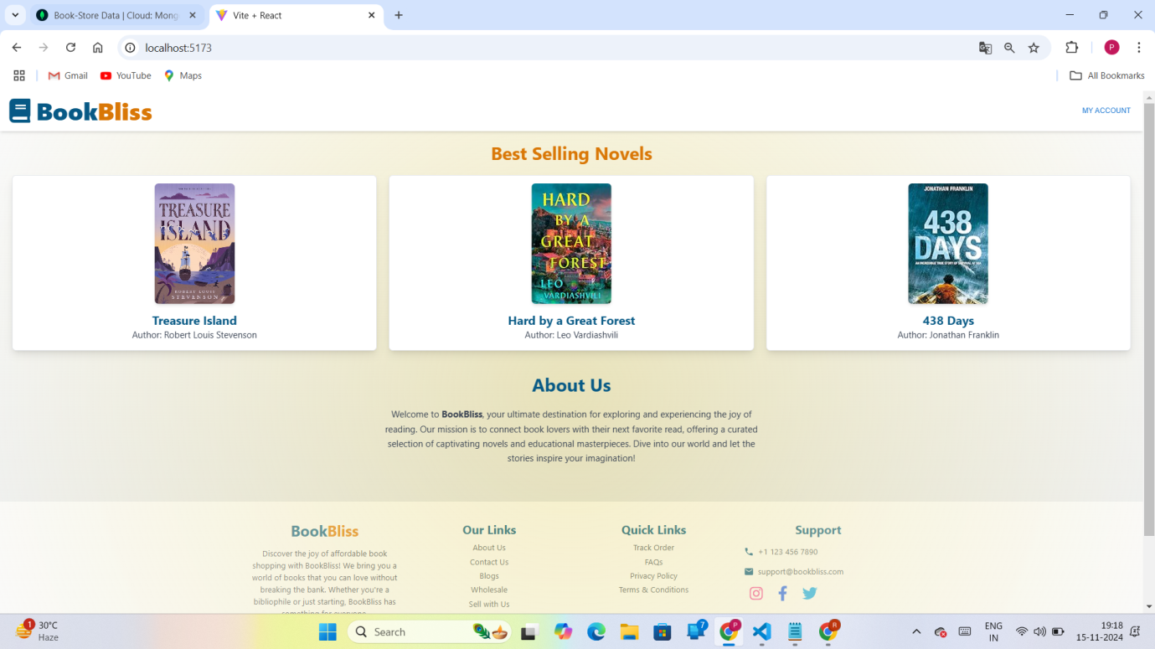

Signup page:

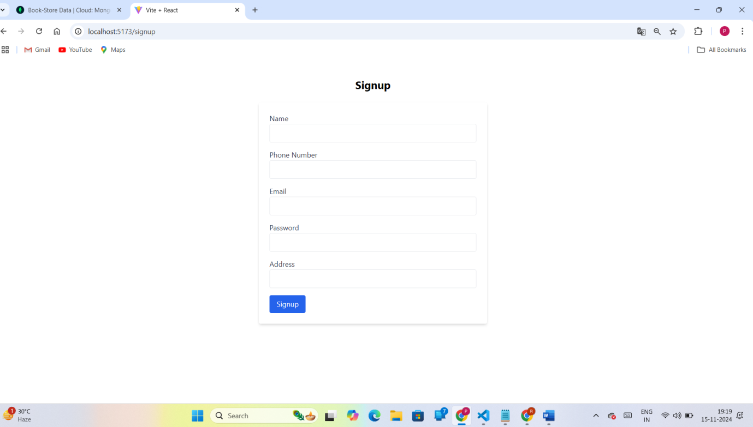

Login page:

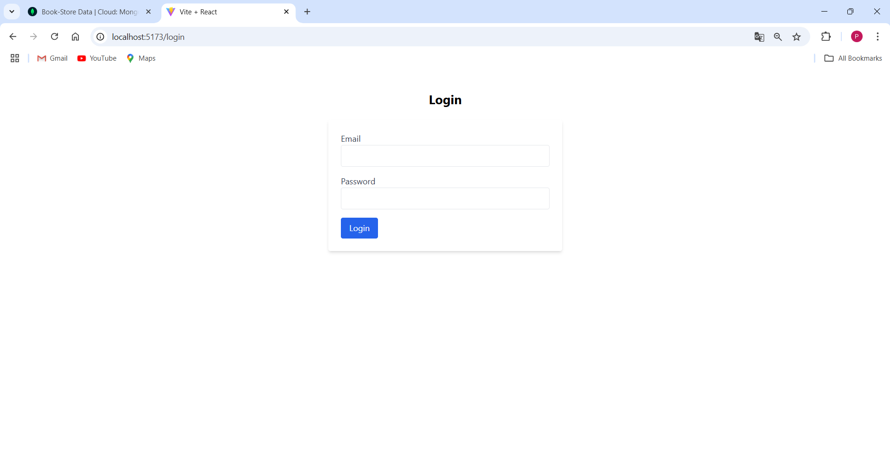

Admin Page:

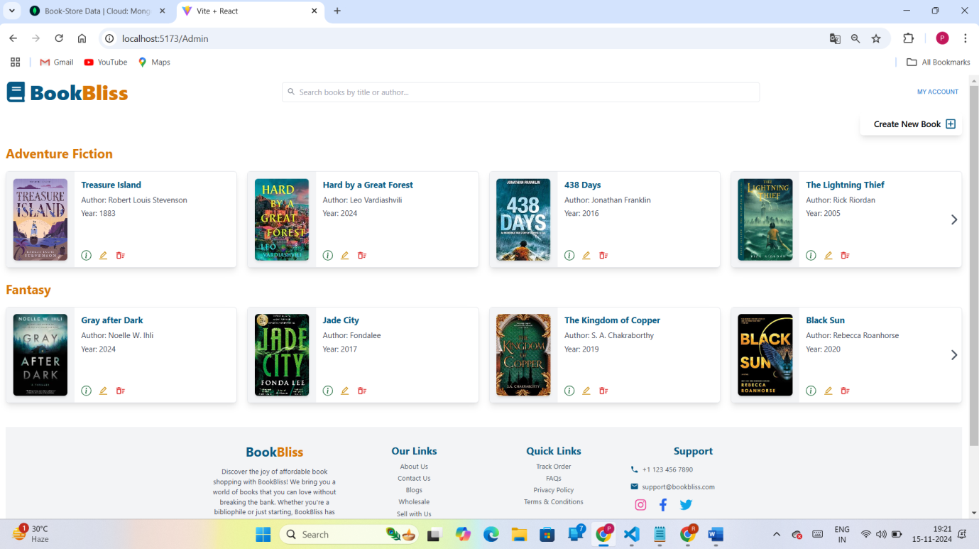

Create Book Page:

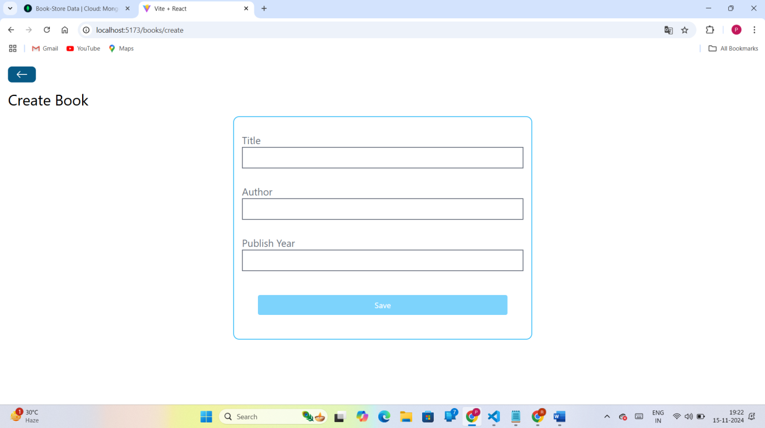

Show Book Page:

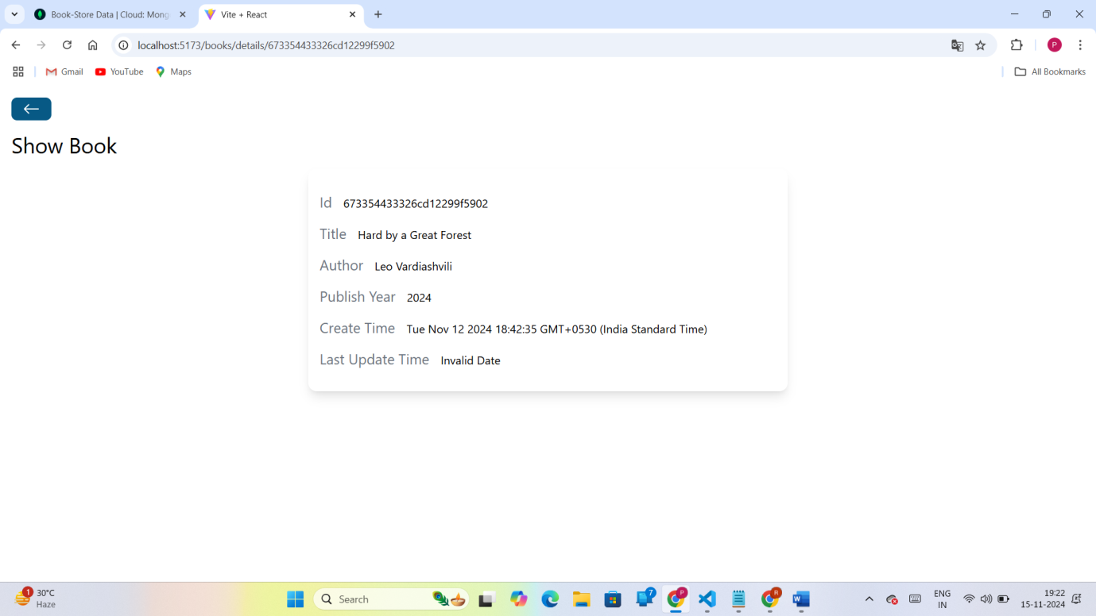

Edit Book Page:

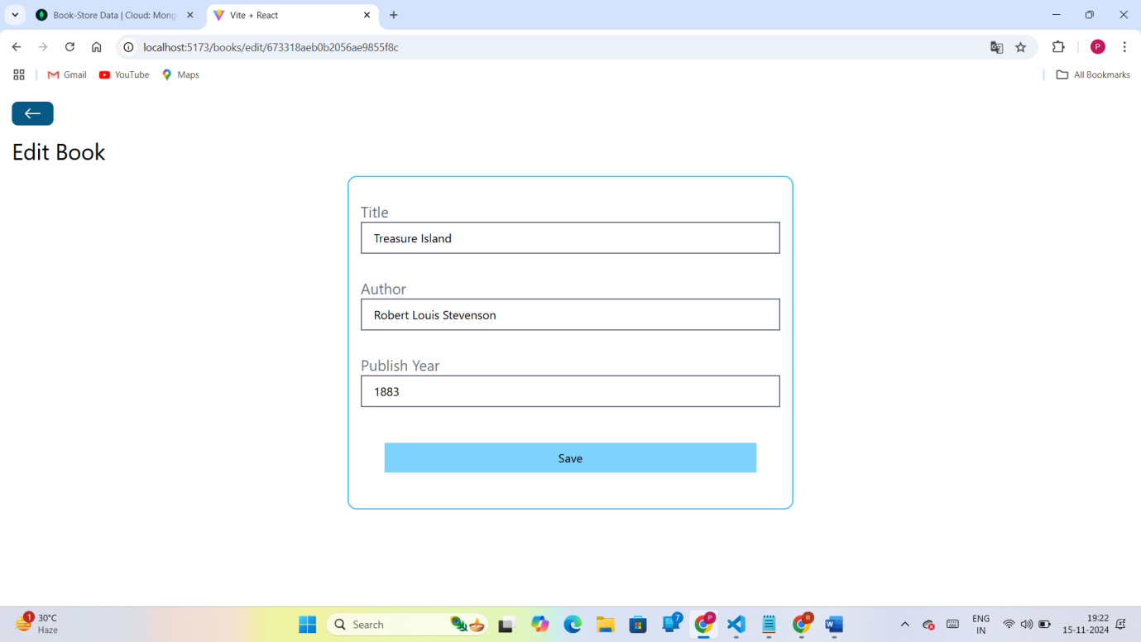

Delete Book Page:

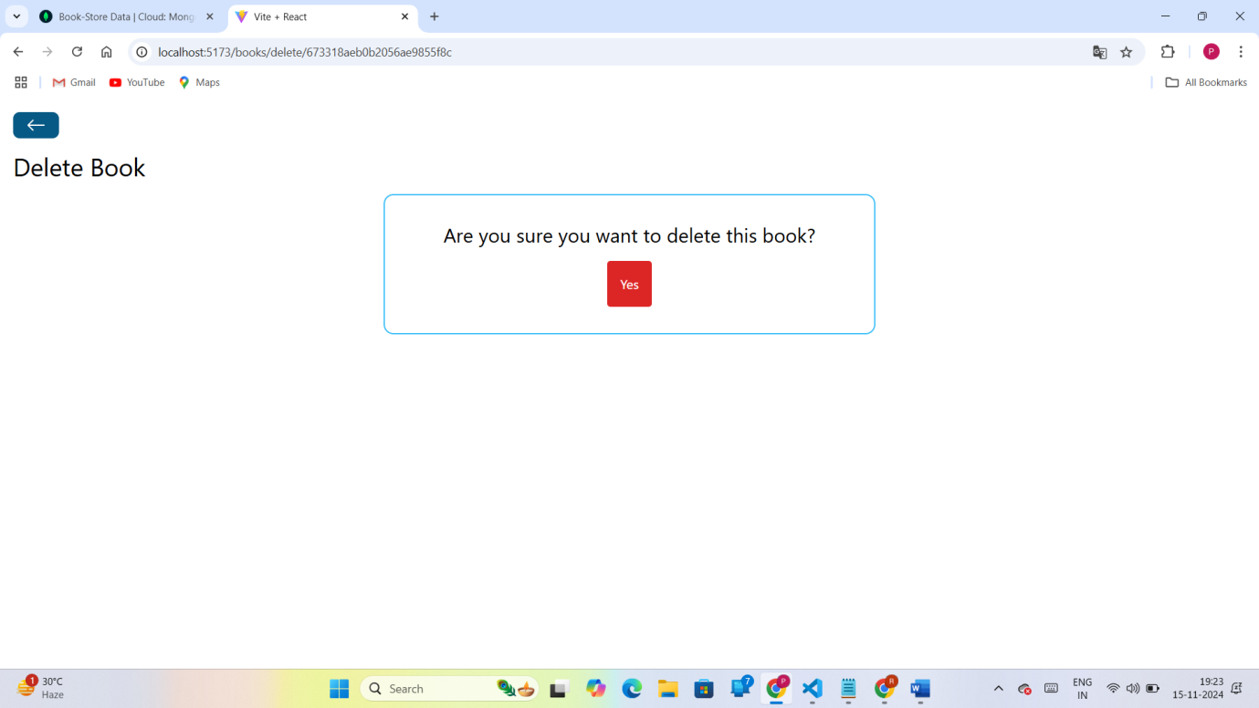

Search Bar:

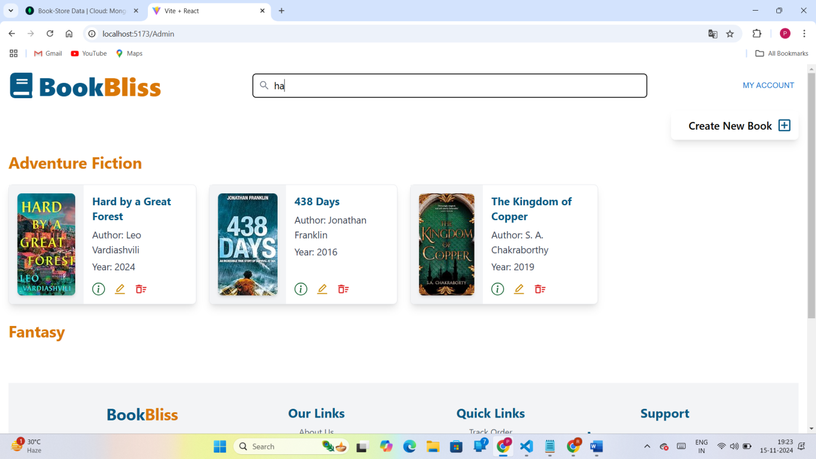

UserUI Page:

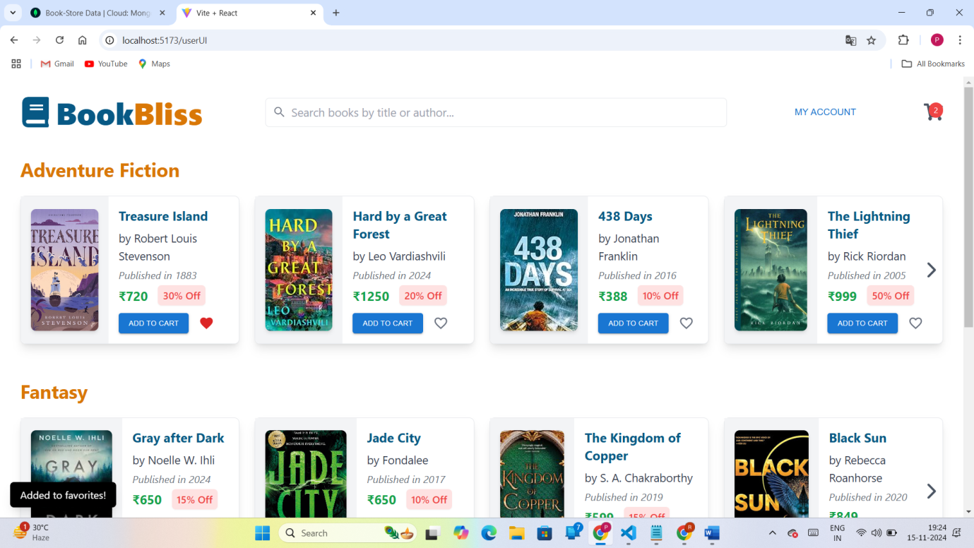

Cart Page:

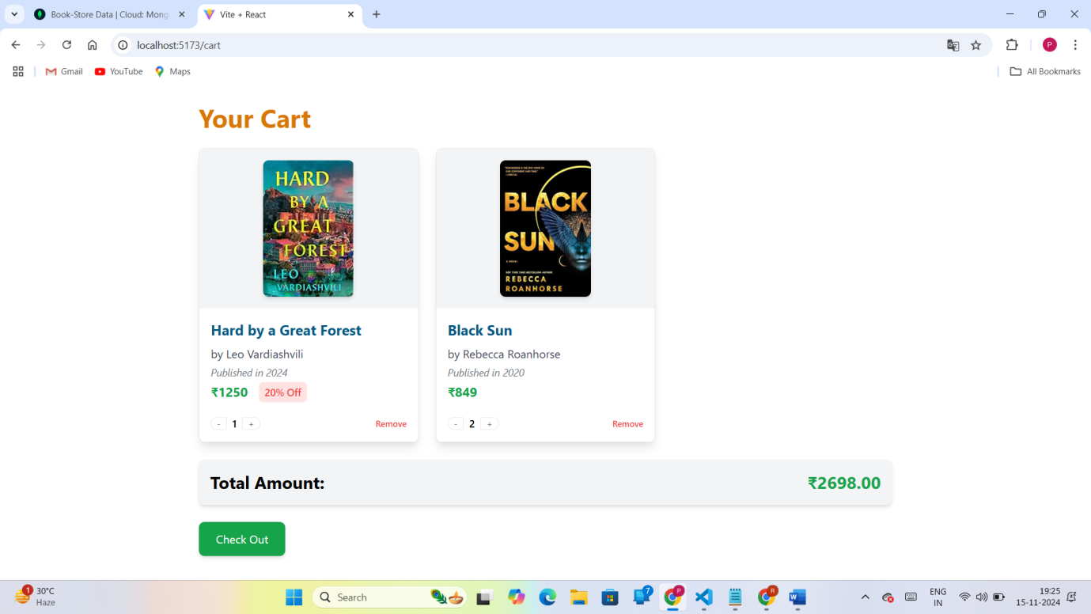

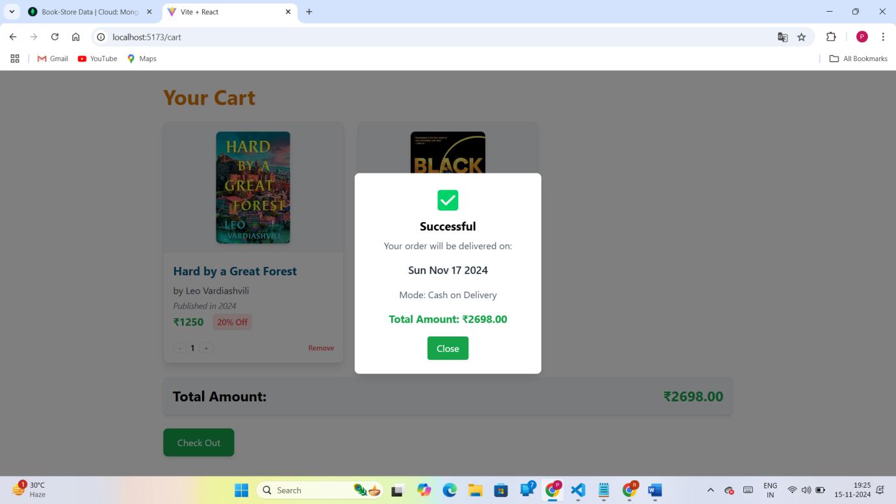

* **Live Demo**: <https://drive.google.com/file/d/1KW7Ww_CGtze23B-B0YbnMKlnBqnLxFyR/view?usp=sharing>

**12. Known Issues**

Some known issues in the current implementation include:

* **Data validation**: Form validation is minimal, allowing for potentially inconsistent data entries.
* **Loading States**: The application may lack loading indicators on certain pages, leading to potential confusion for users if data loading is delayed.
* **Error Handling**: Some error messages are logged to the console rather than displayed to users.

**13. Future Enhancements**

To increase the functionality and value of the Book Store Project, future updates may include:

1. **User Reviews and Ratings**: Enable users to review and rate books, enhancing the decision-making process for potential buyers.
2. **Wishlist Feature**: Allow users to save books for future purchases and receive notifications for discounts or restocks.
3. **AI-Powered Recommendations**: Implement personalized book recommendations based on user preferences and purchase history.
4. **Mobile App Integration**: Develop a mobile app to enhance accessibility and provide a seamless shopping experience across devices.
5. **Loyalty Programs**: Introduce reward points and discounts for frequent buyers to boost user engagement and retention.